VARUN BHARGAVA – 241010282
DATA STRUCTURES TASK-9

Task 01: Restore File Directory from Creation and Listing Logs:
(https://github.com/varunnnb/dsa-sem3-iiitnr/blob/main/lab9/lab9-1.c)
A computer system stores the folder structure of files as a binary tree. Unfortunately, the directory system crashed, and you only have two logs left:
● preorder → the order in which directories and files were created.
● inorder → the order in which files/directories appear when listed alphabetically.
Your task is to rebuild the original folder structure tree and return it.You may assume there are no duplicate directory/file names.
Input:
preorder = ["root","docs","assignments","photos","music"]
inorder = ["assignments","docs","root","photos","music"]
Output:
["root","docs","music","assignments",null,"photos",null]

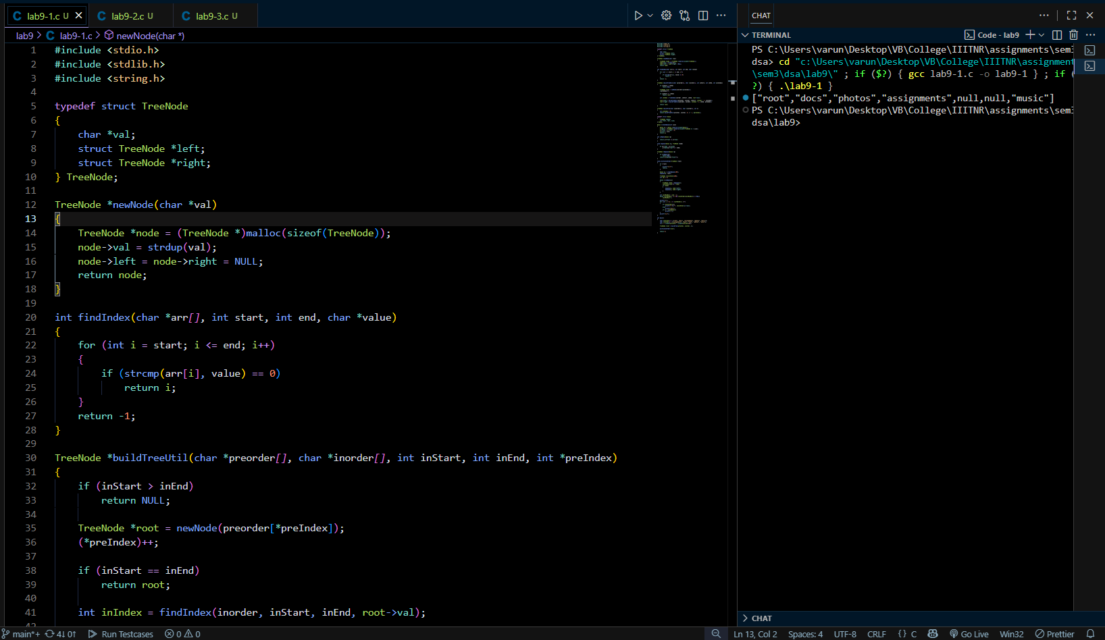
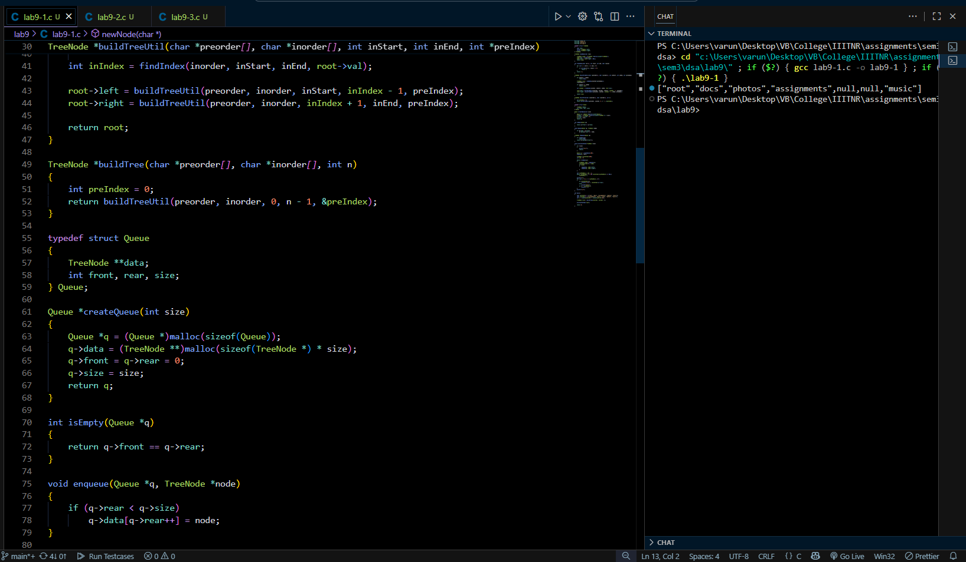
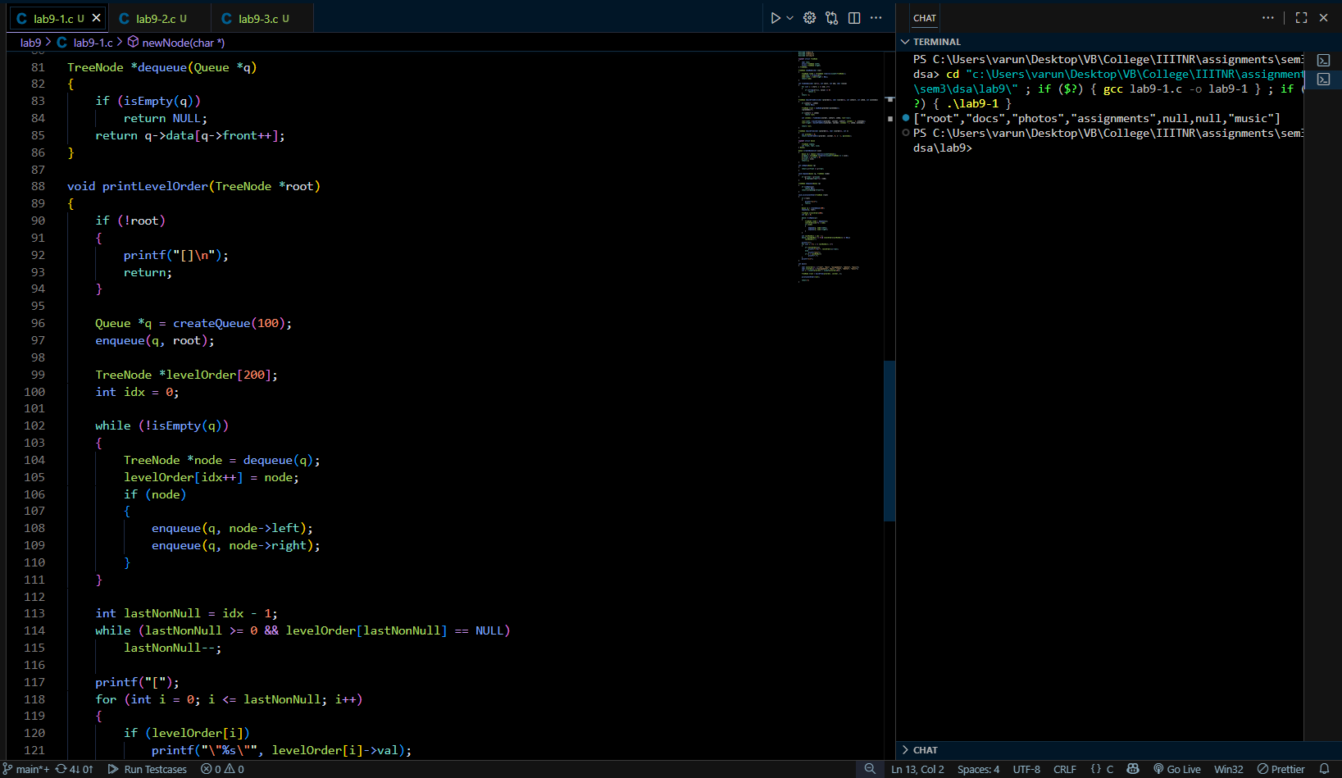
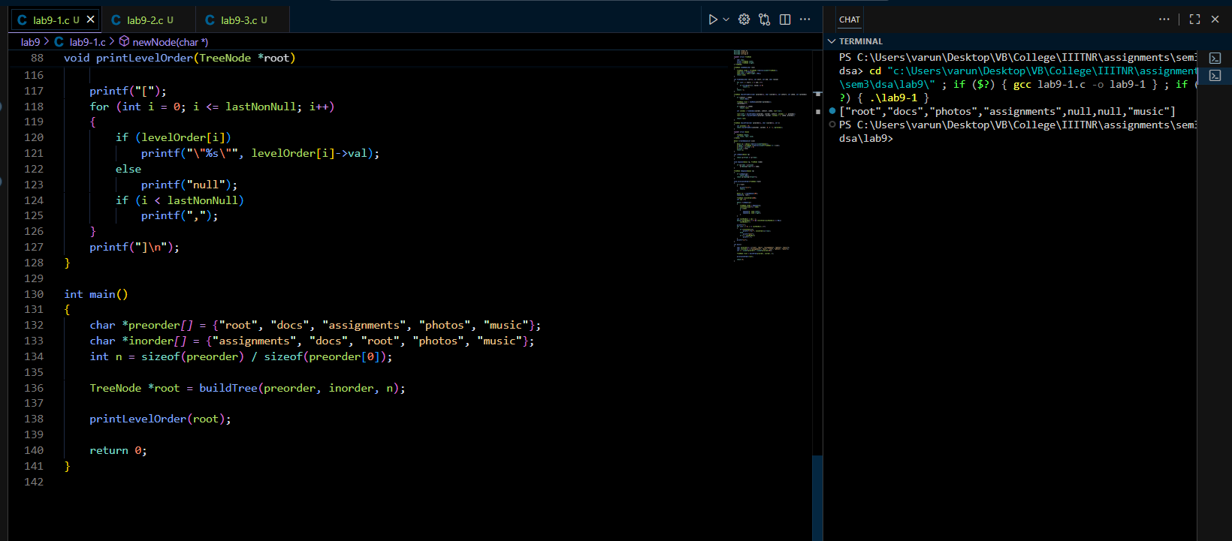

Task 02: Restore Family Tree from Birth Records:
( https://github.com/varunnnb/dsa-sem3-iiitnr/blob/main/lab9/lab9-2.c)
A genealogy company stores family data in two forms:
● inorder → listing of people in chronological order of birth within families.
● postorder → listing of children before their parents.
The database was corrupted, and you must reconstruct the original family tree.

You may assume all names are unique.
Input:
inorder = ["Eve","Adam","Cain","Abel","Seth"]
postorder = ["Eve","Cain","Abel","Seth","Adam"]

Output:
["Adam","Eve","Seth",null,null,"Cain","Abel"]

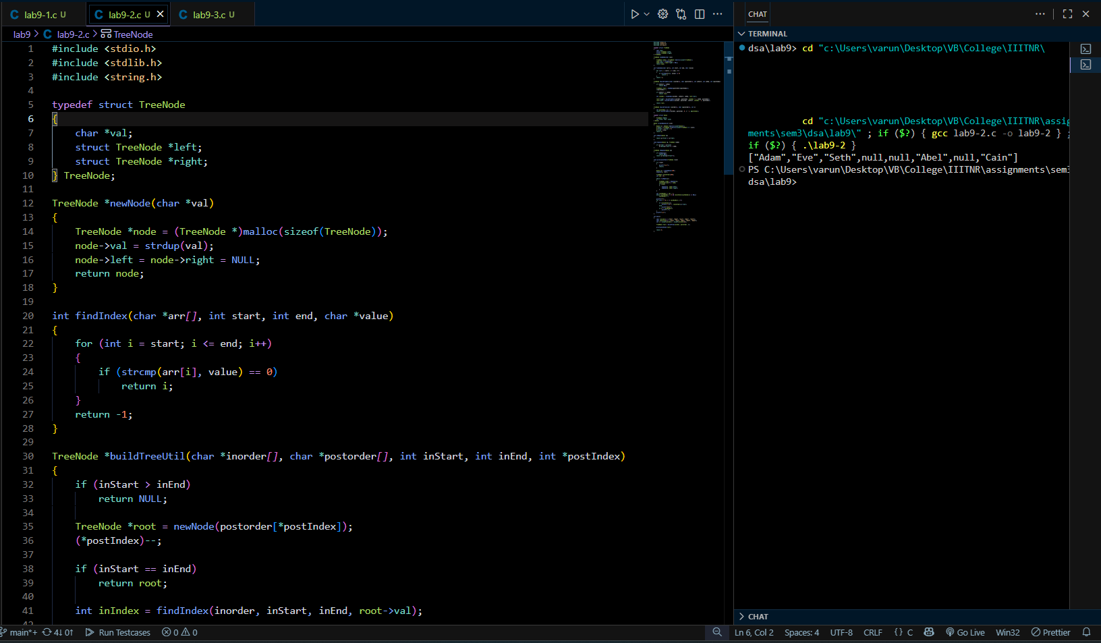
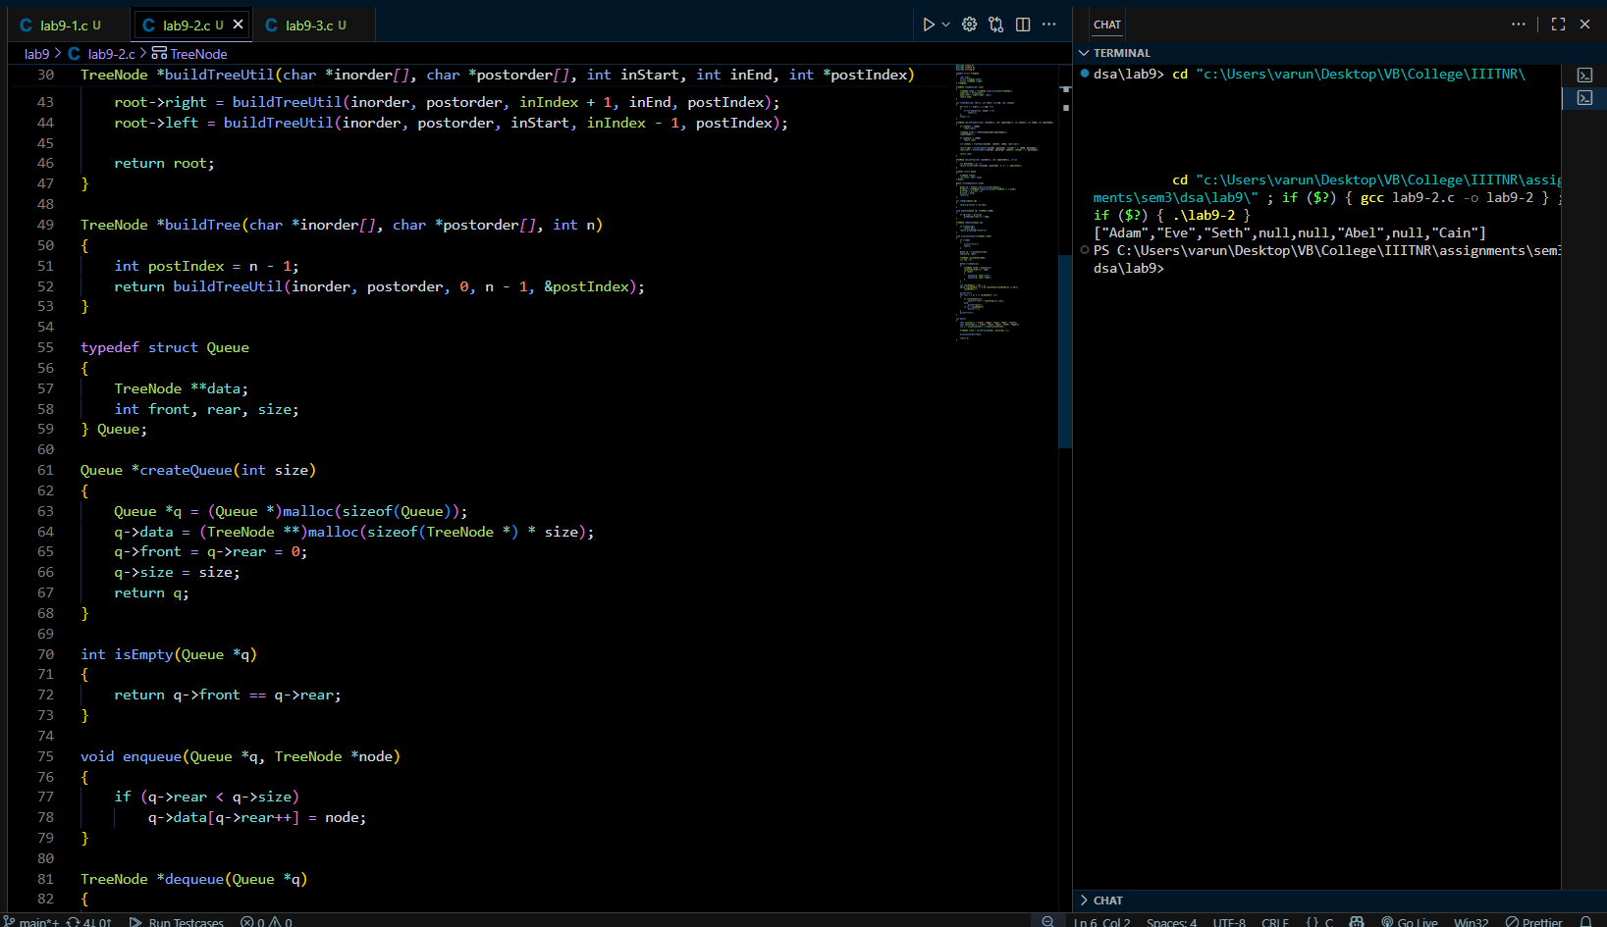
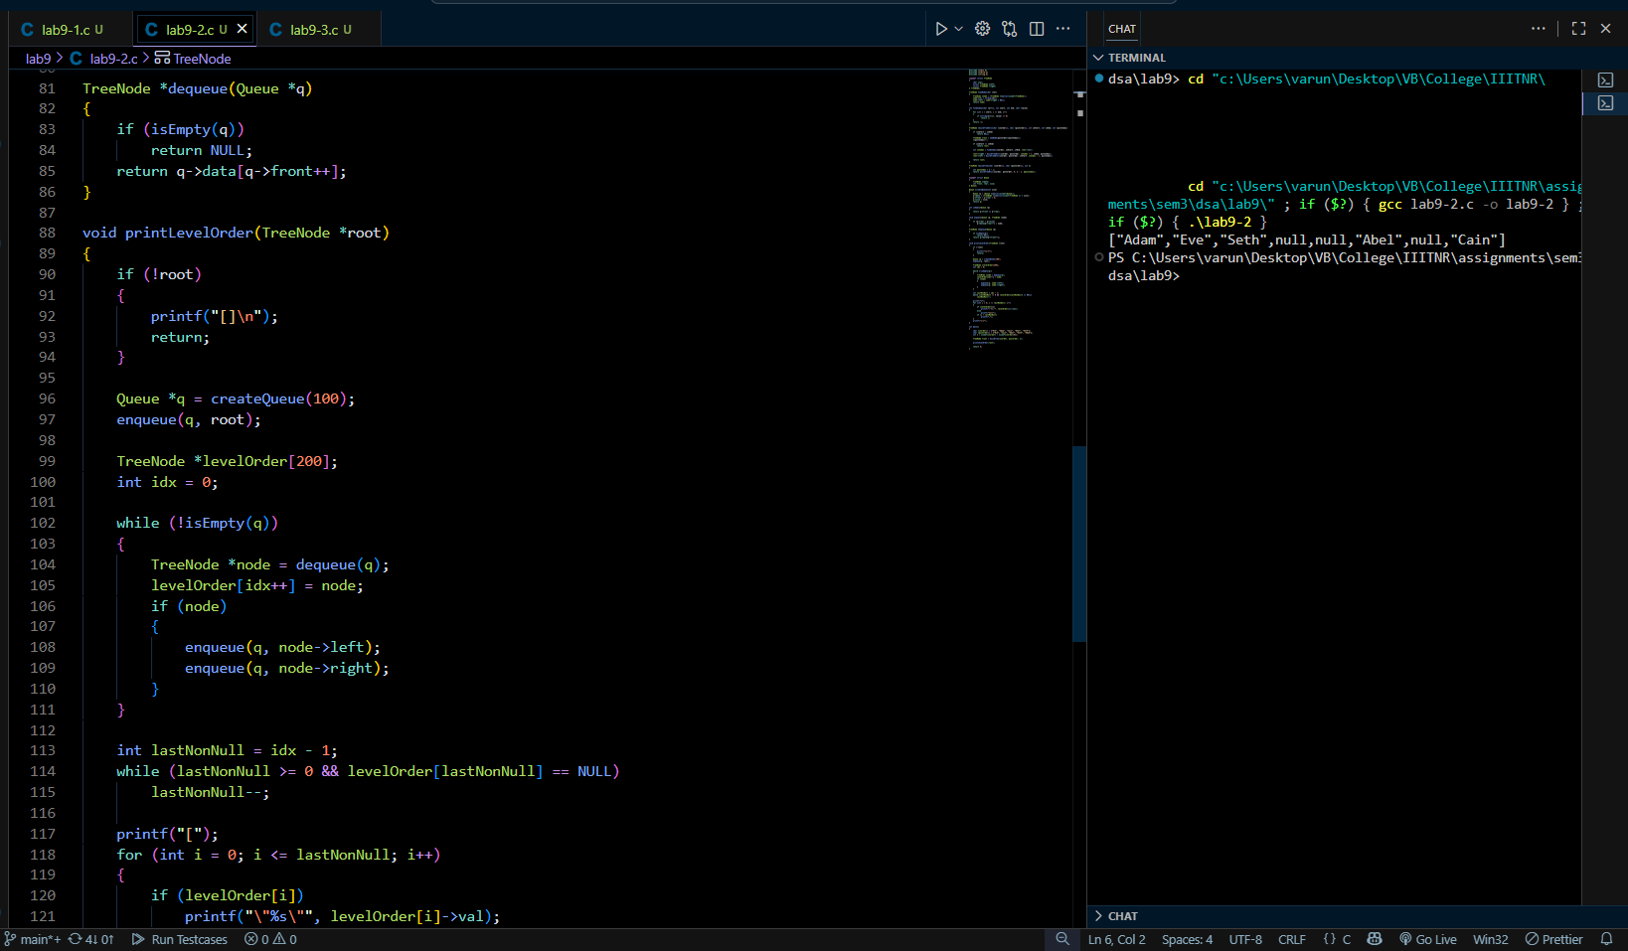
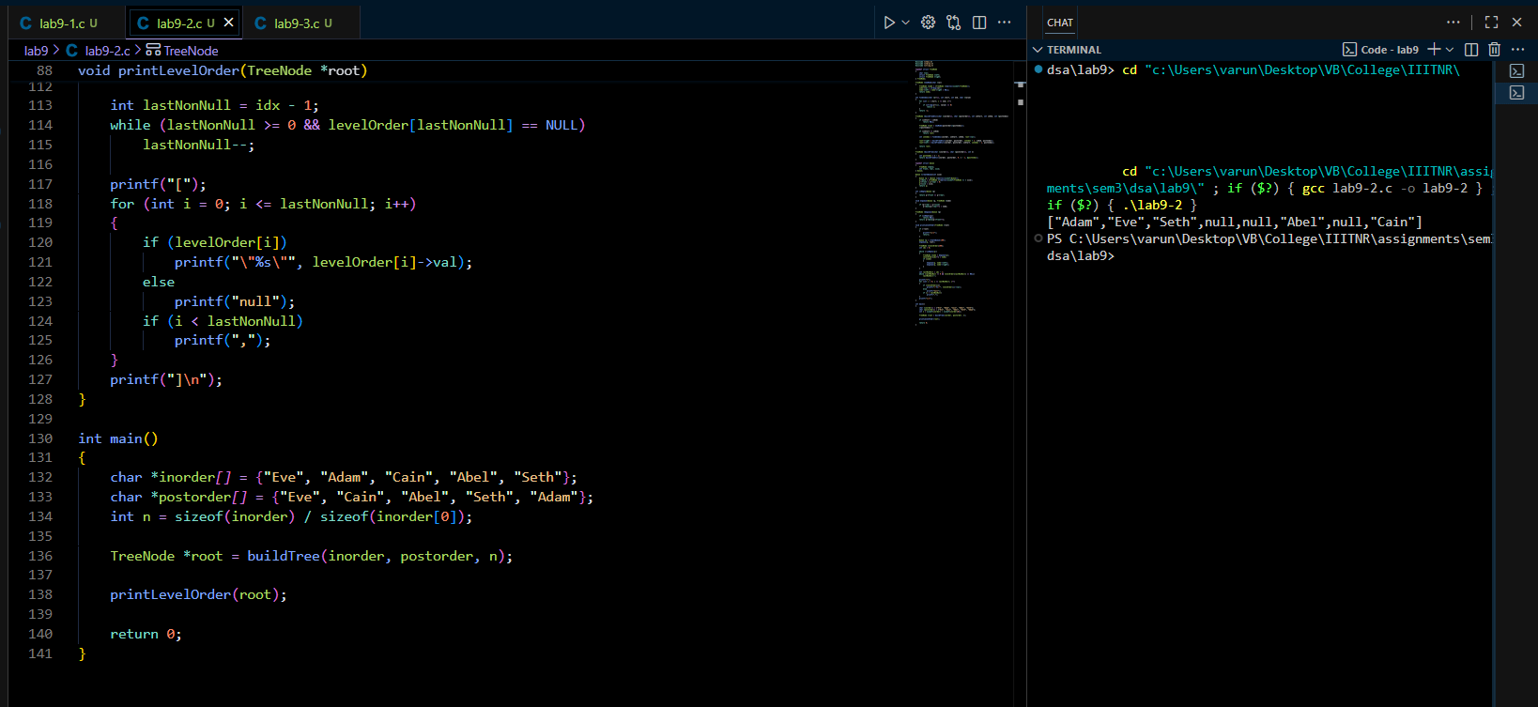

Task 03: Reconstruct Network Topology from Connection Logs:
( https://github.com/varunnnb/dsa-sem3-iiitnr/blob/main/lab9/lab9-3.c )
In a distributed network, servers and routers form a tree topology.

● preorder → the order in which connections were established from the main
server outward.
● postorder → the order in which messages were acknowledged back to the main
server.
Given these two logs, reconstruct the network topology.
If the network is not a full binary tree (where every router has either 0 or 2 connections),
the topology cannot be uniquely reconstructed.
Input:
preorder = [1,2,4,5,3,6,7]
postorder = [4,5,2,6,7,3,1]
Output:
[1,2,3,4,5,6,7]
Input:
preorder = [1,2,3]
postorder = [2,3,1]

Output:
"Network topology cannot be uniquely reconstructed"

